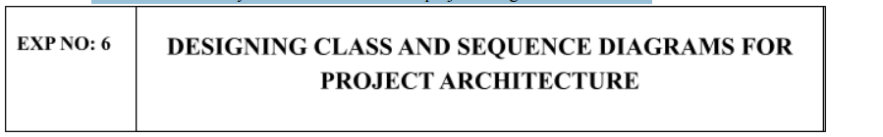
Aim:
To Design a Class Diagram and Sequence Diagram for the given Project.

Class diagram:

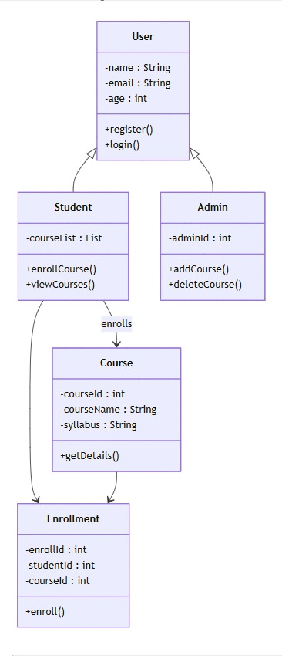

SEQUENCE DIAGRAM :
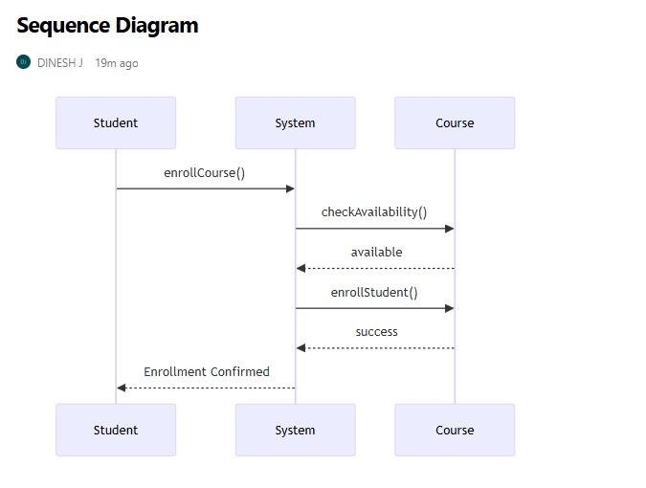

Result:
The Class Diagram and Sequence Diagram is designed Successfully for the Music Playlist Batch Creator.

